Contents
1.0 Executive Summary 2
1.1 Core Project Goals 2
1.2 Current Pain Points 3
2.0 Phase 1 In-Scope Applications and Integration 3
2.1 Technical Approach: The "OOTB-First" Framework 5
3.0 Intelligent Reuse: Accelerating Delivery Without Compromising OOTB 6
3.1 Overall Project Guidelines 6
3.2 Contractual Guardrails and PCR Triggers 7
4.0 7
4.1 Workshop Approach and Engagement Model 8
4.2 Detailed Sprint Sequencing 10
4.2.1 Initiate & Plan: Project Kickoff & Foundational Alignment 10
4.2.2 Execute: Core Build & Employee Experience 11
4.2.3 Deliver: Validation & Readiness 11
5.0 Testing & Acceptance 12
6.0 Organizational Change Management & Training 12
6.1.1 Close: Transition & Strategic Alignment 13
6.2 Phase 1 Timeline & Pricing 14
7.0 Connection Long-Term ServiceNow Roadmap 14
7.1 The ECS Roadmap for Future Expansion 15
7.2 Phase 2: Baseline Expansion & Enhanced User Experience 15
7.3 Phase 3: ITOM and Intelligence 16
8.0 Future Opportunity for Enhanced Functionality around AI & Advanced Automation 17
9.0 Acronyms 17

- Executive Summary
Corporate IT intends to fully reimplement ServiceNow in a new, dedicated instance to replace its current highly customized legacy build. This strategic move is designed to exit a domain-separated environment that currently complicates operations and blocks future expansion. The project prioritizes an "Out-of-the-Box (OOTB)-first" approach, leading with ServiceNow best practices to reduce technical debt and ensure the platform is architecturally ready to leverage modern AI and automation capabilities. Capabilities like Now Assist, Agentic Agents, Predictive and Task Intelligence, and the Workflow Data Fabric depend on a clean OOTB foundation to deliver value — Phase 1 lands that foundation.

A critical success factor for this engagement is the alignment to Common Service Data Model (CSDM) best practices from day one, ensuring a healthy CMDB that can support CI-based change risk scoring and provide the clean data required for AI ROI. This four-month Phase 1 delivery focuses on modernizing ITSM Core processes and standing up a modern Employee Center featuring a Virtual Agent and AI Search to drive ticket deflection and improve the overall employee experience. This Statement of Work also serves as the Project Charter for the engagement.

The delivery follows an iterative Agile methodology, with 2-week sprints commencing immediately following a foundational Sprint 0 dedicated to alignment and governance setup. To ensure long-term platform health, the project establishes a strict governance model to intake and triage business requests, prioritizing them within a feedback-driven backlog based on measurable business needs. Key outcomes will be tracked via Platform Analytics and Success Dashboards, focusing on operational improvements such as MTTR, SLA attainment, and change success rates.
  - Core Project Goals
The ServiceNow reimplementation is driven by the need to move away from a highly customized legacy environment that hinders growth and innovation. The core goals and pain points identified in Connection’s sources are as follows:

The primary objective is to fully reimplement ServiceNow in a new, dedicated instance to replace the customized legacy build. Key goals include:
- Adopting Out-of-the-Box (OOTB) Processes: Leading with best practices provided OOTB for the initial implementation before making iterative adjustments.
- Modernizing Change and CMDB: Aligning to CSDM best practices and modernizing Change Management together with the CMDB to ensure healthy, CI-based risk scoring and data standards.
- Improving Employee Experience: Standing up a modern Employee Center with a mature Knowledge Base, featuring a Virtual Agent and AI Search to drive ticket deflection and improve the user experience.
- Enabling AI and Analytics: Establishing Platform Analytics and AI (such as Predictive/Task Intelligence) to achieve measurable operational improvements and ROI.
- Exiting Domain Separation: Moving to a governed, dedicated instance to remove operational complexities and allow for future expansion.
- Establishing Strict Governance: Implementing a model to intake and triage requests, prioritizing them based on business needs through iterative sprints.
- Ensuring that all purchased SKUs are being used and are optimized.

  - Current Pain Points
The current state is characterized by several challenges that the re-implementation aims to resolve:
- Technical Debt and Customization: Legacy ServiceNow customers with highly customized platforms face difficulties leveraging AI and modern capabilities.
- Low OOTB Adoption: Replicating legacy processes has led to inefficiencies, complexity, and limited scalability.
- Domain Separation Blocks: The current domain-separated environment complicates operations and prevents the platform from expanding.
- User Confusion: Employees are often unsure of where or how to request services due to portal confusion.
- Communication Gaps: There are currently inconsistent customer communications and limited automated updates for requesters.
- Improved CMDB Health: Resetting the CMDB aligned to CSDM prevents the successful use of AI; reducing old technical debt is essential to improving CMDB health and seeing a return on investment (ROI).
- License optimization and realization, certain SKUs are not being optimally utilized

- Phase 1 In-Scope Applications and Integration
The Connection team has identified following applications to be considered in scope for phase 1 of the baseline re-implementation effort:
- ITSM Core: Interactions, Incident, Request, Knowledge, Change (including CAB (Change Advisory Board) workbench and 2 or 3 well-defined standard changes), Problem, Major Incident; Service Operations Workspace.
- Initial Service Catalog: Top 10-15 most impactful existing catalog items with clearly defined activities, workflow, approvals, etc. The current Catalog configuration will be leveraged where it does not introduce technical debt. While Phase 1 focuses on the 10–15 most impactful catalog items, all services must be accounted for in the re-implementation. To ensure no customer is left behind, 2–3 of the Phase 1 items will be designed to be generic enough to capture services that do not yet have a dedicated workflow. Expanded, directed workflows for those services will be delivered in later phases.
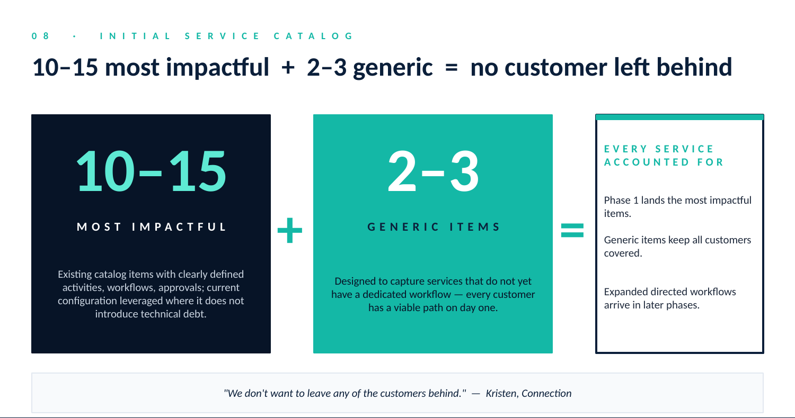
Initial Service Catalog: 10–15 most impactful + 2–3 generic = no customer left behind
- Employee Experience: Employee Center, Virtual Agent, AI Search, and Knowledge Management. Platform Baselines: Subscription Management and Security Center are configured as platform-level baselines to provide license visibility and security posture from day one.
- Automation: Flow Designer, Predictive/Task Intelligence,
- Analytics: Platform Analytics, Data Visualization, Benchmarks.
- CMDB & CSDM: Foundational alignment to CSDM best practices, CMDB, CI relationship standards.
- Discovery & Connectors: Discovery, Service Graph Connectors for SCCM and Intune (populate/normalize CMDB). The current configuration of Discovery will be leveraged where it does not introduce technical debt.
- Agile / DevOps: Agile delivery framework leveraging the ServiceNow Common Workflow Module (CWM); intake and triage model.
- Hardware Asset Management (HAM): Stockrooms and initial HAM foundations (to ensure best practice alignment with CSDM in Phase 1)
- Additional Integrations: AD, SSO for contacts and seamless login. The current configuration of AD/SSO will be leveraged where it does not introduce technical debt.
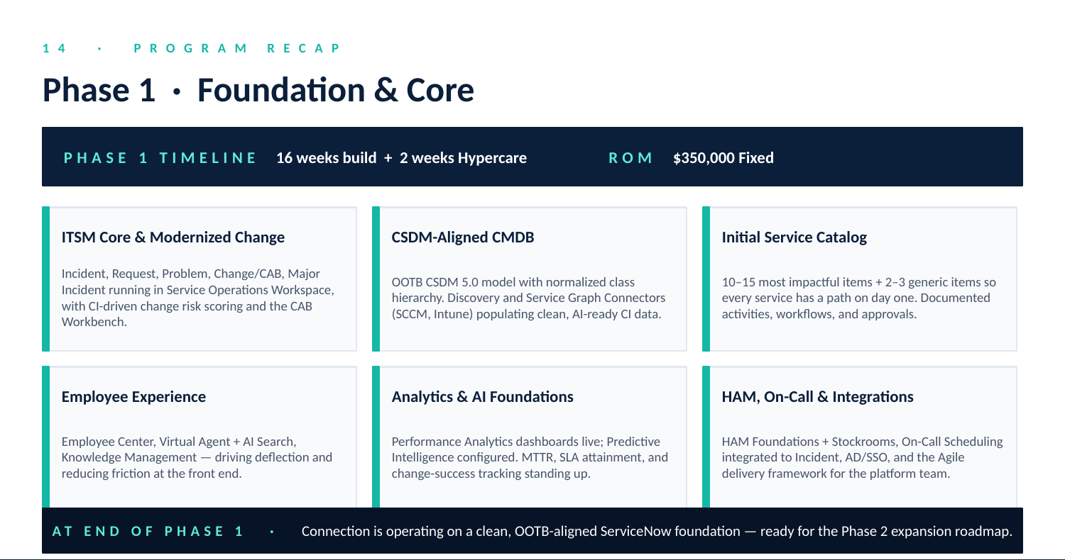
Phase 1 — Foundation & Core: capability summary
AI Alignment Note: Each capability above is selected because it both delivers immediate operational value and is a prerequisite for AI capabilities Connection will leverage in Phases 2, 3, and beyond.

  - Technical Approach: The "OOTB-First" Framework
The goal of the project is to make customization the exception rather than the default.
- Baseline Validation: Every in-scope application’s build will start with a demonstration of the out of the box ServiceNow functionality. Any delta between the baseline and the user story must be justified by a documented business necessity, aligned to current budget and require Project Sponsor sign-off. An acceptable threshold for deviating from OOTB is qualitative: a delta is acceptable only when it is (a) tied to a documented business outcome, (b) cannot be met by configuration of an OOTB capability, and (c) signed off by the Project Sponsor.
- Low-Code/No-Code Governance: Configuration of ServiceNow will focus on the use of Flow Designer, Decision Tables, and UI Builder over custom Script Includes or Jelly/Angular modifications.
- Upgradeability Scorecard: Every configuration is assessed for its impact on future upgrades. If a request creates a "Skipped Record" risk for the next ServiceNow family version (e.g., Australia or Brazil), it is automatically flagged for the Governance Triage Log.
- Core Data Integrity: Enforce strict adherence to the ServiceNow CSDM standard. For example, the use of custom tables instead of standard CI classes is defined as a "Structural Deviation" requiring Project Sponsor approval.

Intelligent Reuse: Accelerating Delivery Without Compromising OOTB
A pragmatic accelerator for the 18-week timeline is the intelligent reuse of Connection's existing platform investments where they align with the OOTB pattern. ECS and Connection's technical leadership will assess current configurations and port them to the new instance where doing so does not introduce technical debt. Where current configurations represent customization or workarounds, they are rebuilt against the OOTB pattern.
- Integration configurations (AD/SSO, Discovery, SCCM/Intune): ECS reviews the current integration designs with Connection SMEs and ports the working configuration where it aligns to current best practices. Reuse preserves Connection's operational knowledge and shortens the ramp on Connection-side dependencies.
- Service Catalog items: Where existing items use OOTB workflow patterns and standard form variables, they are ported and adapted. Where existing items rely on custom Script Includes, Jelly/Angular UI, or non-standard data models, they are rebuilt against the OOTB pattern as part of Phase 1.
- Knowledge articles: KM articles are curated and ported as a baseline for the new KM instance and Virtual Agent / AI Search content. Stale, redundant, or off-pattern articles are retired rather than ported.
The principle: reuse what aligns to OOTB; rebuild what doesn't. This accelerates delivery while preserving the OOTB-first discipline that makes the platform AI-ready.
OOTB-first is not a stylistic preference; it is the architectural prerequisite for the AI features Connection has invested in.
  - Overall Project Guidelines
These guidelines serve as the operational "guardrails" that the ECS team uses daily to keep the project delivery aligned to the project goals and defined scope.
- The "Rule of Three": If a requirement cannot be met by (1) Configuration, (2) UI Policy, or (3) Flow Designer, it is treated as a Customization. Customizations require a separate technical review and a formal impact assessment to scope and budget and approved by the Project Sponsor.
- Definition of Done (DoD): A story is "Done" when (a) all acceptance criteria in the user story have been met and validated by the Product Owner, (b) the configuration adheres to the Rule of Three — Configuration, UI Policy, or Flow Designer — unless a Customization has been approved by the Project Sponsor, and (c) the configuration is documented in the relevant design artifact.
- MVP Mindset (Minimum Viable Platform): To complete this project within the 18-week timeline, delivering a baseline implementation for all in scope applications and achieving a Go-Live by week 16, we will capture secondary requirements in the backlog for the Phase 2 Roadmap, keeping the initial implementation clean.
  - Contractual Guardrails and PCR Triggers
ECS and Connection agree this SOW and Project Charter include the following specific language around Scope Boundaries:
- The "OOTB Baseline" defines the scope specifically as the implementation and configuration of out-of-the-box ServiceNow functionality as defined by the ServiceNow Product Documentation for all in-scope applications.
- Any requirement necessitating custom scripting, modification of protected baseline objects, or creation of custom tables shall be deemed Out of Scope and require a Project Change Request (PCR).
- ECS’s ability to meet the 18-week timeline is contingent upon the delivery of customer dependencies (Foundation Data, Completed Accelerator Pack for foundation data, SSO access, SME availability and assignment) by Sprint 0/1. Failure to meet agreed upon deadlines that cause a project delay may result in a PCR for timeline extension.
- ECS will review current configuration of the existing Service Catalog, Discovery, and in-scope integration configurations with assigned Connection SMEs. ECS will port over configurations, where possible, to expedite the configuration of those applications where it will not introduce technical debt. Lack of availability of Connection SMEs in those areas that cause a project delay may result in a PCR for timeline extension.
- Third-Party Integrations: Any integration not explicitly listed in the original SOW is out of scope. Availability of Connection SMEs is required for any in-scope integration with ECS being responsible for design and documentation of the data integration and the ServiceNow configuration portion of the integration only.
- Connection Long-Term ServiceNow Roadmap
This comprehensive blueprint for Connection ServiceNow Phase 1 reimplementation combines the high-level roadmap narrative with the detailed sprint sequencing required for a successful four-month, Agile-driven delivery.
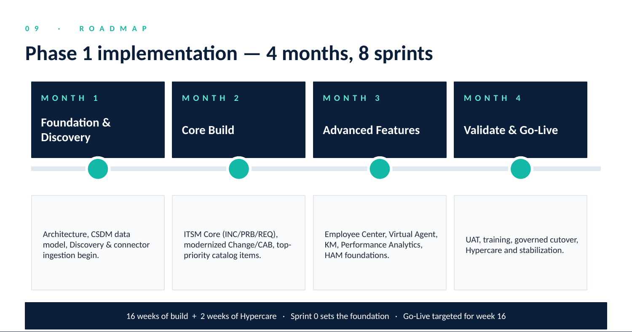
Phase 1 Implementation Roadmap — 4 months, 8 sprints

The project is structured as a "greenfield" implementation in a new, dedicated instance to eliminate legacy technical debt and domain separation.
- Month 1: Foundation and Discovery. The initial focus is on establishing the platform architecture and defining the CSDM and confirming it aligns to the ServiceNow data model. Discovery and Service Graph Connectors (SCCM/Intune) ported from the previous system are initiated early to begin normalizing the CMDB while ITSM design aligns legacy needs with OOTB best practices.
- Month 2: Core Build and Process Modernization. Configuration begins for ITSM Core (Incident, Problem, Request) and the modernized Change/CAB process. The first set of high-priority catalog items is developed during this phase.
- Month 3: Advanced Features and Integrated Analytics. The focus shifts to the Employee Experience (EC/VA, KM) and layering in Platform Analytics (PA) and Hardware Asset Management (HAM). The remaining catalog items (totaling 13–15) are finalized leveraging existing catalog items and workflows when able.
- Month 4: Validation, Readiness, and Go-Live. The final month is dedicated to User Acceptance Testing (UAT), delivering Knowledge Transfer (KT) sessions for admins and train-the-trainer team, and executing the production cutover followed by Hypercare.
  - Workshop Approach and Engagement Model
The Phase 1 engagement is anchored by a structured workshop approach that grounds every design decision in standard ServiceNow OOTB capability before any deviation is considered. ECS’s role across the program is twofold: the consultant guiding Connection through a pragmatic reset of legacy customizations toward an OOTB-first operating model, and the trusted partner helping process owners — particularly those most invested in legacy configurations — see how the OOTB pattern delivers their business intent. Workshops are deliberately short, outcome-oriented sessions where the platform demonstrates the work first, and the conversation focuses on the narrow set of decisions Connection actually needs to make to make it their own.

Workshops are organized into five focus tiers and delivered Just-in-Time against the active sprint backlog, so every session is tied to work that will be configured within days rather than stockpiled as theoretical design.
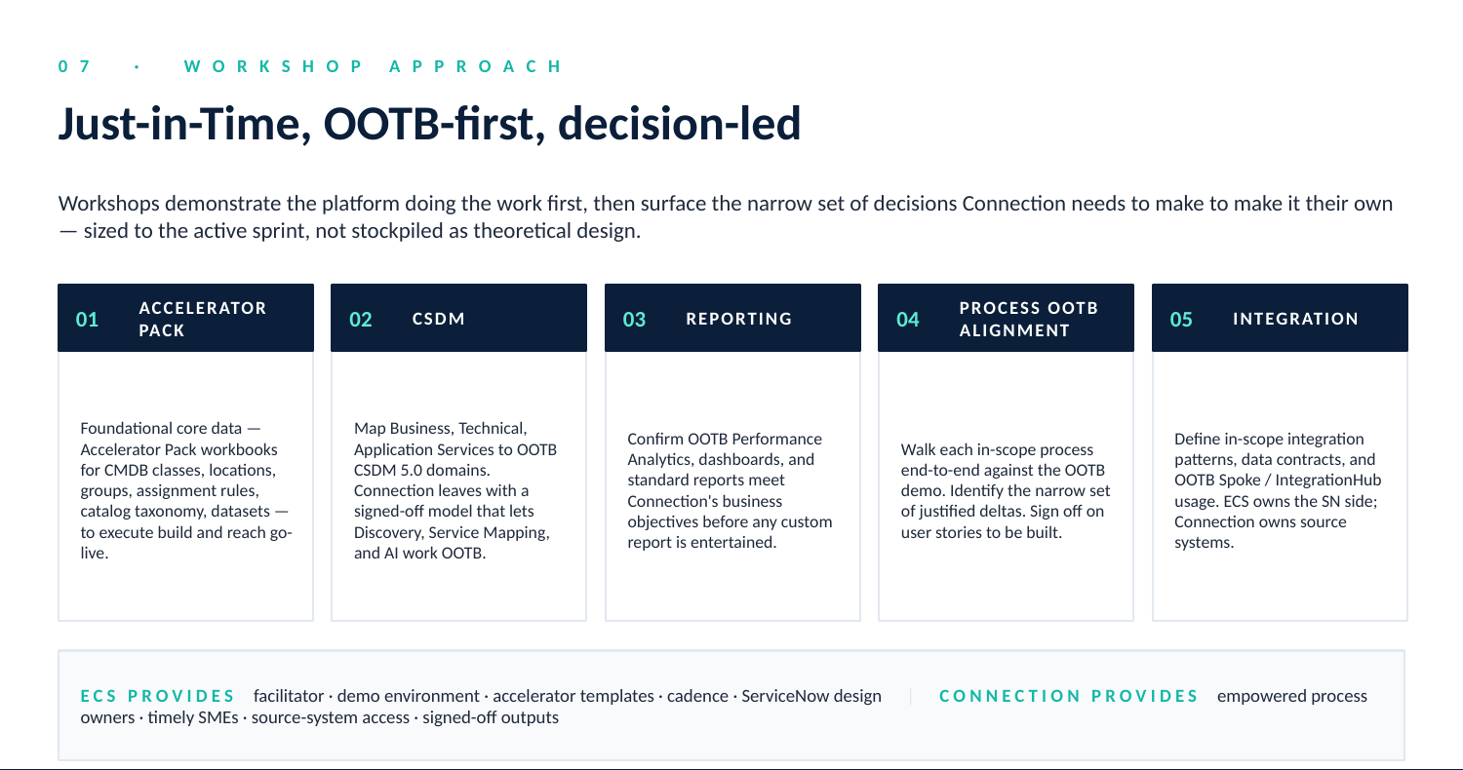
Workshop tiers — Just-in-Time, OOTB-first, decision-led

Accelerator Pack workshops capture the foundational core data — the ECS Accelerator Pack workbooks for CSDM, CMDB classes, locations, groups, assignment rules, catalog taxonomy, and reference datasets — that are required to execute build and reach go-live.

CSDM workshops establish the Common Service Data Model foundation that every downstream workstream depends on. Anchored in OOTB CSDM principles, ECS facilitates working sessions that map Connection’s Business, Technical, and Application Services to the standard design domains (Foundation, Design, Build, Manage, Sell/Consume) and lifecycle stages. Connection leaves the workshop with a documented, signed-off CSDM-aligned data model, clear domain ownership, and a normalized class hierarchy — the prerequisites that let Discovery, Service Mapping, Performance Analytics, and downstream AI features work OOTB without bespoke scaffolding. Any deviations from the standard model are documented as justified exceptions with an OOTB-first remediation path.

Reporting workshops confirm that OOTB Platform Analytics, dashboards, and standard reports meet Connection’s business objectives before any custom report is entertained.
Process-specific OOTB alignment workshops walk each in-scope process (Incident, Request, Change, HAM, etc.) end-to-end against the OOTB demonstration, identify the narrow set of justified deltas, and sign off on the user stories that will be built.

Integration workshops define in-scope integration patterns, data contracts, and OOTB Spoke / IntegrationHub usage.

Roles and responsibilities are clear in every workshop ECS provides the facilitator, the demonstration environment, the Accelerator Pack templates, the meeting cadence, and the ServiceNow-side design; Connection provides empowered process owners with decision-making authority, timely SME availability, source-system access for integrations, and signed-off workshop outputs that feed directly into the active sprint backlog. This rhythm — demonstrate OOTB, confirm fit, justify only the necessary delta, configure within the sprint — is the mechanism by which the program eases legacy product owners into the OOTB reality without losing the business context they bring, while keeping the consultant-led reset on its 18-week trajectory.
  - Detailed Sprint Sequencing
The 18-week engagement follows a strict Agile methodology, with iterative cycles starting on day one, leveraging 2-week sprints.
    - Initiate & Plan: Project Kickoff & Foundational Alignment
- Sprint 0: Project Setup & Governance (Weeks 1–2)
Upgrade Posture: The instance will be upgraded to the latest available ServiceNow release prior to the start of configuration. If a new release becomes available mid-engagement, ECS will assess upgrade implications with stakeholders and define a path (pre-go-live, post-go-live during O&M, or deferred).
  - Activities: Formal kickoff, SOW review, completion of ECS Accelerator Packs (workbooks for configuration baseline and datasets), and establishing a strict governance strategy to triage and manage the backlog.
  - Focus: Aligning on roles, responsibilities, and acceptance criteria for all deliverables.
- Sprints 1 & 2: Core Data & CSDM Foundation (Weeks 3–6).
  - Activities: Executing/documenting CSDM mapping, defining CI relationship standards, and configuring greenfield instance basics (SSO, AD, roles, Foundation Data imports, SLAs.
  - Focus: Ensuring a healthy, standardized CMDB to unlock future AI and automation.

Project Management & Delivery Artifacts
Deliverable Name | Phase | Description
Integrated Project Schedule (IPS) | Initiate | The master timeline (IPS) tracking all milestones, ECS resource tasks, and client dependencies across the 18 weeks.
Agile Sprint Plan | Initiate | A defined backlog of stories mapped to Sprints 1–8, establishing the "Definition of Ready" for each iterative build.
ECS Accelerator Packs | Initiate | Standardized configuration workbooks and datasets used to establish a rapid, clean-slate baseline for the new environment.
CSDM & CMDB Blueprint | Initiate | A technical map of the Common Service Data Model (CSDM) architecture, CI relationship standards, and Foundation Data mappings.
    - Execute: Core Build & Employee Experience
- Sprints 3 & 4: ITSM Core & Modernized Change (Weeks 7–10)
  - Activities: Building INC, PRB, CHG, and REQ workflows in the Service Operations Workspace. Implementing CI-driven change risk scoring and the CAB Workbench.
  - Focus: Replacing customized legacy processes with streamlined OOTB workflows.
- Sprint 5: Employee Experience & Automation (Weeks 11–12)
  - Activities: Standing up the Employee Center (EC), configuring the Virtual Agent (VA) with AI Search, Knowledge Management (KM) workflow and Articles (ported from legacy system as a baseline) and implementing initial Predictive Intelligence.
  - Focus: Driving ticket deflection and improving the end-user request experience.

Execute Project Artifacts & Deliverables
Deliverable Name | Phase | Description
Sprint Review & Sign-off | Execute | Formal documentation at the end of every 2-week cycle confirming stakeholder acceptance of the "Definition of Done" for that sprint. Sprint scope and acceptance criteria are agreed at sprint planning; Definition of Done is signed off at sprint end.
Requirements Traceability Matrix (RTM) | Execute | A compliance bridge linking SOW requirements to specific ServiceNow configurations and their corresponding UAT test cases.
Technical Design Document (TDD) | Execute | A high-level architectural record of the instance setup, focusing on integrations (SSO/AD), core CSDM mapping, and SLAs.
Governance Triage Log | Ongoing | The primary record for managing OOTB compliance; tracks requested deviations and the consultative decisions made to avoid technical debt.
    - Deliver: Validation & Readiness
- Sprint 6: Testing & Analytics (Weeks 13–14)
  - Activities: Conducting System Integration Testing (SIT) and UAT. Finalizing Platform Analytics dashboards for MTTR and SLA tracking.
  - Focus: Validating that the configuration meets all functional requirements and business needs.
  - Note on Testing: ECS tests each story and then hands off the stories to the SME for testing. ECS completes end-to-end testing of the process to ensure that all things work together. Prior to UAT, where the business end-users are engaged, ECS will develop the UAT plan and communicate the approach to targeted Connection user acceptance testers. UAT will focus on the ability for testers to validate a process, for example submitting a ticket - triage and assignment (auto) - solving the incident, summarizing it and closing it.

Testing & Acceptance
ECS executes a layered testing approach so defects surface early, the platform is validated end-to-end, and Connection's sign-off is informed and confident.
- Story-level testing (per sprint, ECS): Each user story is tested against its acceptance criteria within the sprint. Defects are logged and triaged before sprint sign-off.
- System Integration Testing (SIT) — Sprint 6, ECS-led: End-to-end testing across modules and integrations confirming the configured platform behaves as a connected whole. Integration touchpoints (AD/SSO, Discovery, SCCM/Intune, Service Graph Connectors) are exercised against representative scenarios. SIT exit criteria: zero P1 defects open; P2 defects carry documented mitigations.
- User Acceptance Testing (UAT) — Sprint 6, Connection-led with ECS support: Connection's designated user acceptance testers execute a UAT plan developed jointly with ECS ahead of testing. UAT scenarios focus on end-to-end business workflows (submit ticket → triage → assign → resolve → close) and the integrations that support them. ECS provides the test plan template, environment readiness, and daily defect triage. Connection provides the testers, the time, and the sign-off authority.
- Defect management during UAT: Defects are logged in the project backlog, triaged daily by a joint ECS/Connection team, and resolved against severity targets (P1: 24-hour resolution; P2: 3-business-day resolution; P3: deferred to backlog with sponsor agreement).
- Regression testing: For each defect resolution that touches a previously tested area, ECS runs targeted regression on the affected scenarios.
- Formal UAT Sign-off: Required before go-live, with documented entry/exit criteria, a scenario coverage matrix, and a named Connection approver. UAT sign-off is a hard gate on the Go-Live Readiness Checklist.
- Sprint 7: Training, Cutover & Hypercare (Weeks 15–16)
  - Activities: Delivering KT sessions and training materials for internal teams. Executing the governed migration to the new instance and providing post-launch support. KT delivery includes virtual sessions for the platform admin team and workshops for Connection training staff, plus train-the-trainer materials. Formal UAT sign-off is required prior to go-live, with documented entry/exit criteria and a named approver as part of the Go-Live Readiness Checklist.

Organizational Change Management & Training
A successful go-live is as much about adoption as it is about configuration. Connection has elected to own the organizational change management (OCM) and training rollout for the new platform; ECS supports that ownership with knowledge transfer, materials, and a train-the-trainer model. Roles and responsibilities are summarized below.
Activity | Owner
OCM strategy, communications plan, stakeholder engagement | Connection
Change champion network and adoption monitoring | Connection
End-user training delivery and rollout schedule | Connection
Adoption metrics tracking and post-launch reinforcement | Connection
Knowledge Transfer sessions for Connection's platform admin team | ECS
Train-the-trainer materials (decks, recordings, exercises) | ECS
"Admin 101" SOPs and runbooks | ECS authored, Connection signed off
Recorded session library for ongoing reference | ECS

ECS recommends OCM activities begin in Sprint 4 and run through Hypercare. While Connection owns delivery, ECS will participate in joint planning sessions to keep training aligned with the configuration and rollout cadence. Adoption is the strongest leading indicator of platform value — the AI capabilities Phase 1 lands and Phases 2 and 3 build on are only as effective as the user base that engages with them.
  - Focus: Ensuring organizational readiness and a clean exit from the legacy domain-separated environment.

Deliver Project Artifacts & Deliverables
Deliverable Name | Phase | Description
UAT / SIT Plan & Validation Report | Deliver | A summary of testing responsibilities, results, defect resolutions, and formal sign-off confirming the solution meets business functional needs.
Go-Live Readiness Checklist | Deliver | The "Go/No-Go" gate assessing environment stability, data migration readiness, and organizational training completion.
Cutover Runbook | Deliver | A granular, hour-by-hour technical execution plan for the production migration, including rollback triggers and communication trees.

    - Close: Transition & Strategic Alignment
- Sprint 8: Hypercare & Final Closeout Handover (Weeks 17–18)
  - Activities: Finalizing post-go-live Hypercare support and stabilizing the production environment. Conducting a formal Project Closeout including the archival of project artifacts, final sign-off on deliverables, and a comprehensive Lessons Learned workshop to document successes and areas for improvement. ECS provides a standard Hypercare baseline of two weeks of dedicated post-go-live support, daily standups in week 1 stepping down to twice-weekly in week 2, and a formal exit-criteria review prior to handover to steady-state operations.
  - Focus: Performing a final Roadmap Review (roadmap planning discussions begin 6–8 weeks prior to project completion) to align on the long-term vision, ensuring a seamless transition of operations to the internal team, and establishing the path for future enhancements.

Close Artifacts & Deliverables
Deliverable Name | Phase | Description
Knowledge Transfer (KT) Library | Close | A curated repository of SOPs, "Admin 101" guides SOPs are authored by the ECS project team and reviewed/signed off by Connection.
Lessons Learned & Closeout Report | Close | A final summary of project KPIs, successful OOTB adoptions, and the strategic roadmap for the client's next 12 months.

  - Phase 1 Timeline & Pricing
The included timeline and pricing are considered a Rough Order of Magnitude (ROM) following the approach in this document:
- Timeline: 16 weeks with 2 weeks of Hypercare. Timeline can be adjusted through mutual agreement and contract modification.
- Pricing ROM: $350,000
- Connection Long-Term ServiceNow Roadmap
In addition to the initial goals outlined in Phase 1 – Foundation and Core, the Connection team has outlined an expanded strategy for future consideration. Each area of the roadmaps execution strategy will follow the same core principles focused on baseline configuration aligned to business outcomes and OOTB configuration best practices. That expansion includes the following:
- Full Service Catalog implementation:
- Advanced IT Operations Management (ITOM): Implementing bi-directional Event Management for managing Events from multiple monitoring systems (e.g., Splunk, SCOM, SolarWinds, Datadog, ScienceLogic) in ServiceNow and Service Mapping for a complete picture of the business and technical services and relationships in the CMDB, informing the CAB on Change risk and fault tolerance.
- IT Asset Management (ITAM): The ECS Phase 1 approach includes Stockrooms and HAM Foundations, which includes a full implementation of HAM to support complete HW Asset Lifecycle Management. The full implementation of Software Asset Management (SAM) is tied to entitlements and the CMDB ??needs?? to have a complete license position to ensure compliance.
- Additional Service Graphic Connectors: Potential integrations include Databricks, Boomi, reviewing potential business case for integrations like Atlassian, UKG, and E1.

  - The ECS Roadmap for Future Expansion
Each phase compounds the AI readiness of the platform — Phase 1 lands the data foundation, Phase 2 enriches the operational depth, Phase 3 brings ITOM and intelligence into reach. The Future Opportunity section that follows describes the AI horizon this discipline opens.
Once the baseline is established, the foundation for the expansion roadmap is set. ECS recommends the following Roadmap for Future Expansion, systematically building on the Phase 1 baselined and OOTB aligned ServiceNow platform. Timelines and Pricing in Phase 2 and Phase 3 are nominal for now and can be used for general budgetary and timeline estimates. Once Phase 1 is complete, these phases can run in parallel or sequentially, or a combination of both with proper planning, commitment, and coordination.

  - Phase 2: Baseline Expansion & Enhanced User Experience
ECS recommends expanding that baseline focusing on 6 key areas:
- Full Service Catalog: as noted in Connections Expanded Roadmap, expanding on the Phase 1 set of 10-15 catalog items/workflows, with Phase 2 focusing on a core set of 18-20 Business and Technical Services and their supporting catalog items, and Phase 3 evaluating approach and business needs to consolidate to an intuitive set of 50-70 directed catalog items/workflows with documented approvals, serial and parallel processing, etc., that support those Business/Technical Services.
- Virtual Agent Expansion: Phase 1 focused on an initial set of prebuild topic blocks, (e.g., Check IT Ticket Status, Reset Password, Search Knowledge Base). Using the Virtual Agent Designer, the expansion will help refine Connection’s accuracy by configuring Keyword Aliases and Topic Discovery, the Connection’s can accurately route users to automated solutions or live agents, significantly increasing ticket deflection and improving the overall employee experience.
- On-Call Scheduling: the baseline On-Call Scheduling configuration will use the On-Call Wizard to ensure the setup is compliant with the native CSDM and prevents the custom scripting when linking schedules to Incident Assignment Rules. The implementation will focus on setting up schedules and rotations, escalation policies and communication triggers.
- HAM Expansion: Phase 1 focused on getting the Stockrooms and HAM foundation data in place, with the HAM expansion focusing on lifecycle automation. The OOTB approach leverages the Context Service (comparing found assets from Discovery/SCCM/Intune against the Context Library to normalize asset models) and Flow Designer to leverage the six OOTB asset lifecycle workflows integrated to Incidents and Changes.
- SAM Foundation: the SAM Foundation implementation focuses on visibility (what is installed) and normalization through the Context Service & Library for models, given your current software installation baseline. Custom Discovery patterns for non-standard software are not included in Phase 2 but will be flagged for the backlog.
- Additional Service Graph Connectors: integration for Vonage, potential for Boomi and discovery around Databricks; please see the “Future Opportunity…” section below around potential long-term strategy for data sources where ServiceNow may have value accessing the data in other systems but doesn’t necessarily need to consume that data.

Phase 2 Timeline: 12 to 14 weeks
Phase 2 ROM: $150,000 to $185,000. Note” additional evaluation of catalog consolidation effort is required in order to determine final estimate

  - Phase 3: ITOM and Intelligence
To continue the baseline expansion roadmap using the OOTB approach, with a mature CMDB in place, this phase will focus on ITOM (Event Management and Service Mapping), ITAM managing the full Hardware and Software Asset Lifecycle (HAM and SAM), and automating On-Call Scheduling for the ServiceDesk.
- Event Management: Event Management OOTB baselining would include integration to Connections Event data sources (SolarWinds, AWS, etc), enabling Deduplication collapsing repetitive events into one ServiceNow record. Creation of Even Rules using OOTB regex binding events to the CSDM compliant CMDB from Phase 1. Creation of correlation rules to help with root cause analysis and prevention of alert storms. While other integrations identified for the roadmap are one-way, consumed by SN, the event integration(s) would be by-directional to close the loop on events.
- Service Mapping: Implementing Service Mapping requires a mature CMDB be in place. With focus on the Foundation & Core in Phase 1, and continued expansion in Phase 2, the CMDB foundation is in place to build out Service Mapping. ServiceNo-provided patterns will be leveraged for building out the initial service map; custom patterns that are identified will be documented in the backlog for future consideration and cost estimation.
- SAM Expansion: Phase 2 (SAM Foundations) created the system of record and visibility into what software is installed. In Phase 3, ECS focuses SAM Expansion on tying entitlements (what is owned) to software assets. This activity creates a true license position identifying overall software spending, optimization opportunities when overspending, true-up needs when out of compliance, and audit risks.

Phase 3 Timeline: 12 to 14 weeks
Phase 3 ROM: $100,000 to $125,000 (Note: final pricing will be based on additional discussions around the number of and health of Connection’s entitlements)

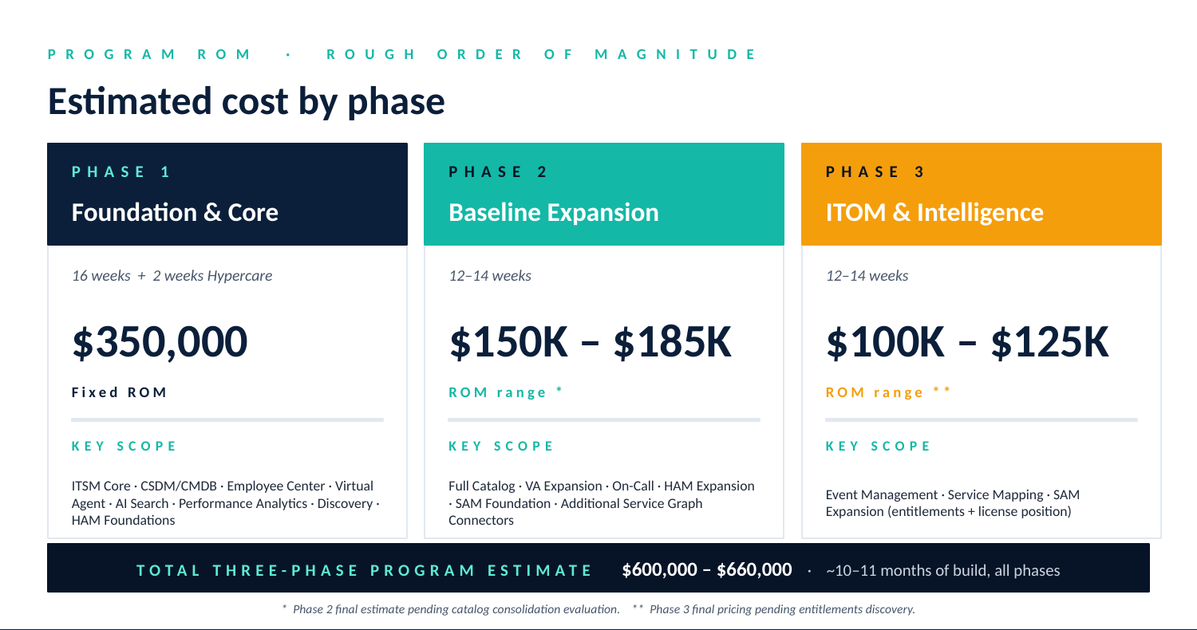
Three-phase ROM summary — Foundation, Expansion, Intelligence
- Future Opportunity for Enhanced Functionality around AI & Advanced Automation
Once Connection’s three-phase ServiceNow program has been fully implemented and aligned to OOTB best practices with very limited or NO technical debt, the Connection team can look to continue to expand, embrace more automation leveraging AI through Now Assist / Agentic Agents, explore using new features like Workflow Data Fabric for “Zero-Copy” integration where systems like Boomi, Databricks, Atlassian, UKG, or E1 may provide data to help ServiceNow end-users make informed or automated decisions that leverage ServiceNow AI, without the need to ingest and save the data in the ServiceNow database.

As part of Phases 1 through 3, the ECS Account team, which includes your Account Executive, Customer Success and Delivery Leadership, will help educate on ServiceNow releases, help with license understanding and optimization, and work collaboratively with Connections to adjust the roadmap, provide scope implications, etc., as new or adjusted business priorities arise.
- Acronyms
The following acronyms are used throughout this document:
CAB — Change Advisory Board
CMDB — Configuration Management Database
CSDM — Common Service Data Model
CWM — Common Workflow Module
ECS — ECS Federal (the delivery partner)
HAM — Hardware Asset Management
HW — Hardware
IPS — Integrated Project Schedule
ITAM — IT Asset Management
ITOM — IT Operations Management
ITSM — IT Service Management
KPI — Key Performance Indicator
KT — Knowledge Transfer
MVP — Minimum Viable Product
OCM — Organizational Change Management
O&M — Operations & Maintenance
OOTB — Out of the Box
POP — Period of Performance
SAM — Software Asset Management
SLA — Service Level Agreement
SOP — Standard Operating Procedure
SOW — Statement of Work
UAT — User Acceptance Testing
UI — User Interface
VA — Virtual Agent

